

Message from the Chair

March 2020

2020 Quota rebate

All of us in General Practice recognise the ever-increasing challenge of COVID-19 faced by colleagues throughout the UK, and I have absolutely no doubt that over the next several months support from LMCs will be required more than ever before.

To relieve a little of the pressures you face, the Board of GPDF has agreed to immediately reduce your quota by 25% (1p per patient, from 4p to 3p) for 2020. Where the 2020 quota has been paid in full the LMC may opt for a payment by BACS or credit toward the 2021 quota.

Together with the recent fall in global stock markets this will increase the downward pressure on our funds but we understand that you may need financial support now.

Thank you all for the valuable work you do for our GPs.

Best wishes

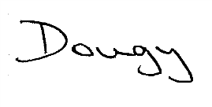

Douglas Möderle Lumb
Chair
General Practitioners Defence Fund Limited


